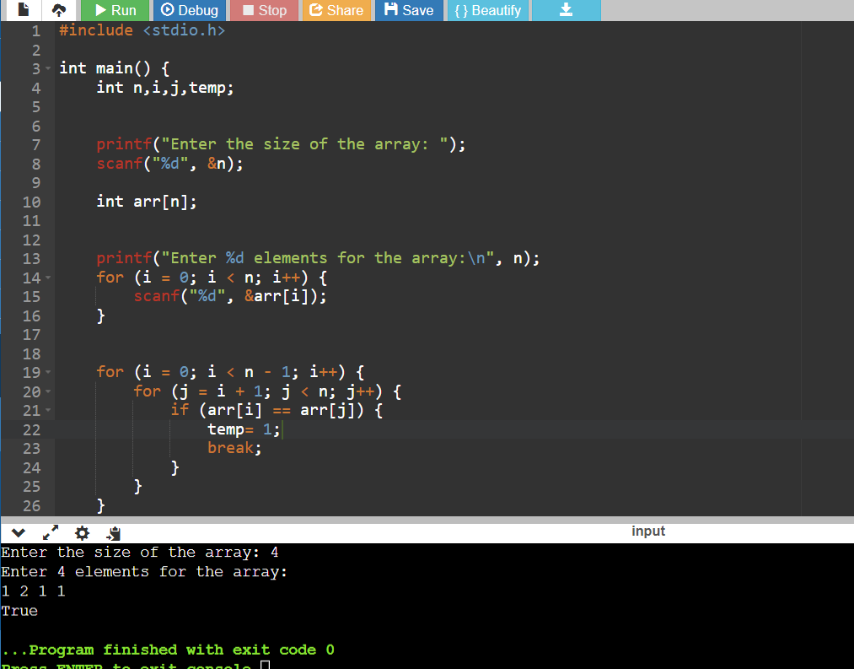

Code:

#include <stdio.h>

int main() {

int n,i,j,temp;

printf("Enter the size of the array: ");

scanf("%d", &n);

int arr[n];

printf("Enter %d elements for the array:\n", n);

for (i = 0; i < n; i++) {

scanf("%d", &arr[i]);

}

for (i = 0; i < n - 1; i++) {

for (j = i + 1; j < n; j++) {

if (arr[i] == arr[j]) {

temp= 1;

break;

}

}

}

if(temp==1)

{

printf("True");

}

else

{

printf("False");

}

return 0;

}